

**Project Report**

**on**

**[E-Commerce WEB APP]**

Submitted to

**LOVELY PROFESSIONAL UNIVERSITY**

for

**INT-220**

**SERVER SIDE SCRIPTING**

**Submitted By Submitted to**

**PALAK BHUSHAN**  **Dr. Vivek Bhardwaj**

**11902209**

**LOVELY FACULTY OF TECHNOLOGY & SCIENCES**

**LOVELY PROFESSIONAL UNIVERSITY**

**PUNJAB**

**April 2022**

**CONTENT**

|  |  |  |
| --- | --- | --- |
|  |  |  |
|  |  |  |
|  |  |  |
|  |  |  |
|  |  |  |
|  |  |  |
|  |  |  |
|  |  |  |

**CHAPTER 1**

***INTRODUCTION***

* 1. **Introduction**

As per the assigned task we were required develop a website using PHP

with the database integration.framework with simple and elegant toolkit and to create full featured web application. I have built a To-Do list web app using the above-mentioned technologies and deployed the operations such as Add, Delete and storing the data into the My-Sql Database. This web can help the user to basically manage their daily task and get them completed on time ones the task is done the user can also delete the task using the interface and add the new task. At the end of the card the user can see the total number of pending tasks. If we look in to the data base, we can also see the time when the task was created so the user can easily manage their time and complete their work o time.

* 1. **Advantages to To-Do List Web App**
* User Friendly and easy to use interface.
* Multiple tasks can be added.
* After completion the task can be deleted just on a single click.
* Every detail is stored in the MYSQL database.
* The user can manage to remember their task and get them done on time.
* At the end the total number of ending task are also visible.

**CHAPTER 2**

***Technologies used***

1. HTML 5
2. CSS3
3. JAVASCRIPT
4. PHP
5. MYSQL
6. BOOTSTRAP 5
7. WEB HOSTING

**CHAPTER 3**

***Modules***

**Module 1**

**PHP PROJECT**

Created the Laravel project using the command line interface with all required dependences using the command: composer create-project laravel/Laravel TO-DO LIST”.

To use this command the composer, Laravel and PHP must be downloaded on the system and it creates the basic project setup with all required files and we can make changes using any code editor as I have used VS code in this project.

**Module 2. The VS Code file structure**

The created file structure is visible on the left-hand side of the vs code page as shown in the image below: -

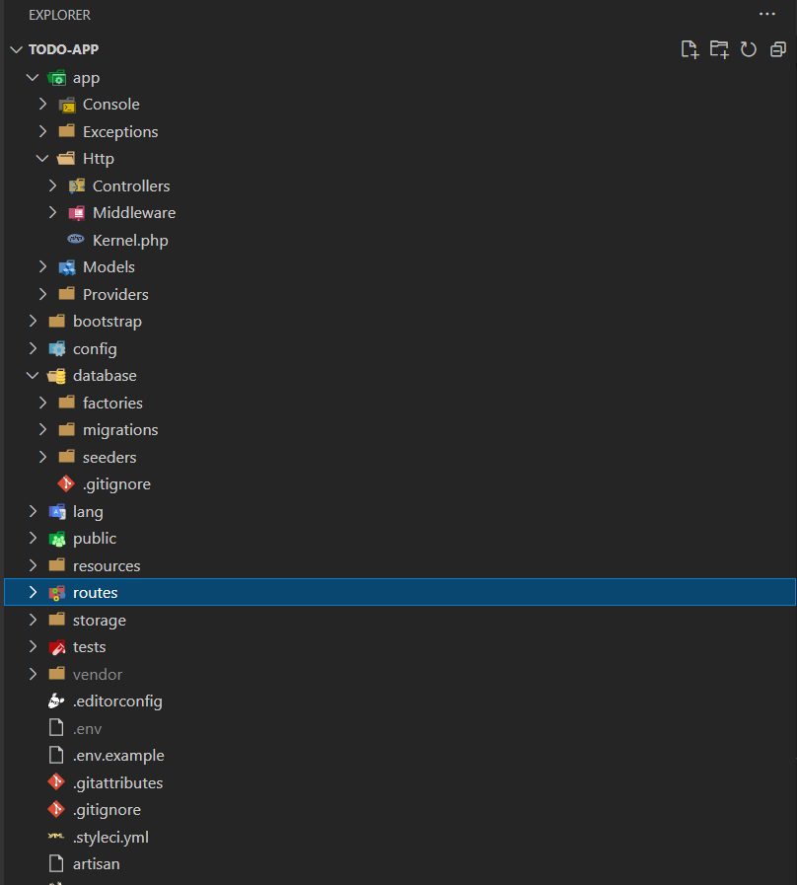

**Module 3. Creating Database using MYSQL in SQLYOG**

I have created a database using MYSQL in the SQLYOG to store the data of the TO-DO List web App so that the user can check all the details in the back database.

The Screenshots are shown below: -

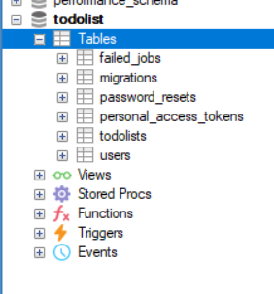

As shown, I have created a data base named “todolist” and inside that there is the table called “todolists” which will consist all the data and will store in the form of table. All other tables are created using “php artisan migrate” command.

The Screenshot of the created table is also attached below: -

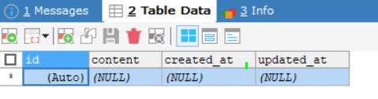

Currently the table is empty as no data is inserted from the frontend.

**Module 4. The snapshot of the different code files.**

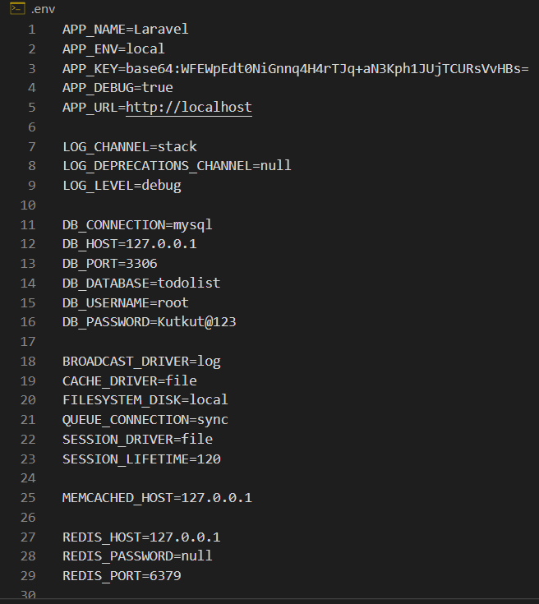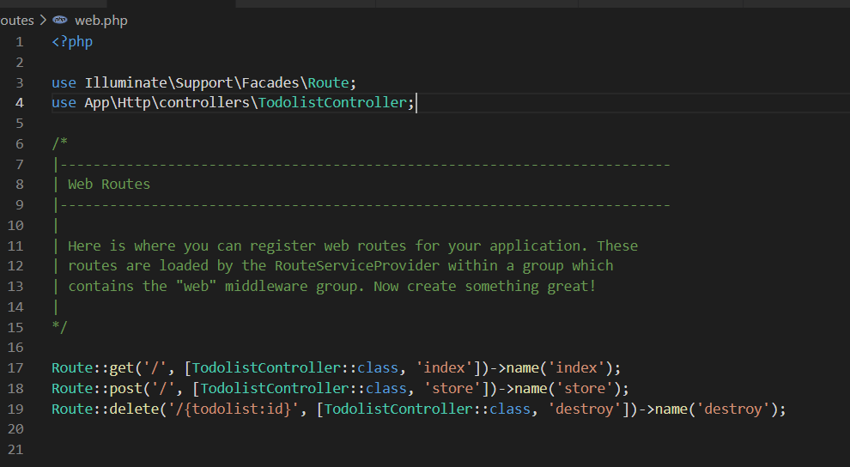

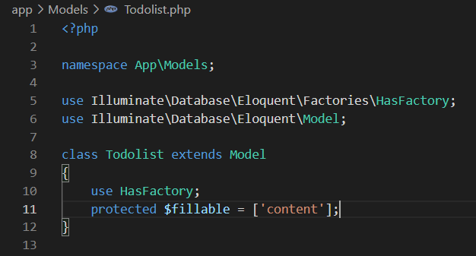

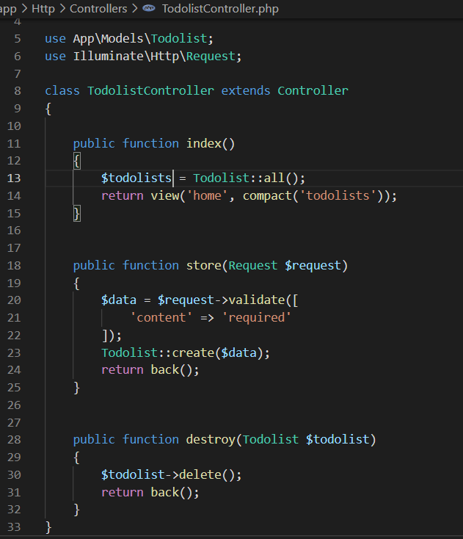

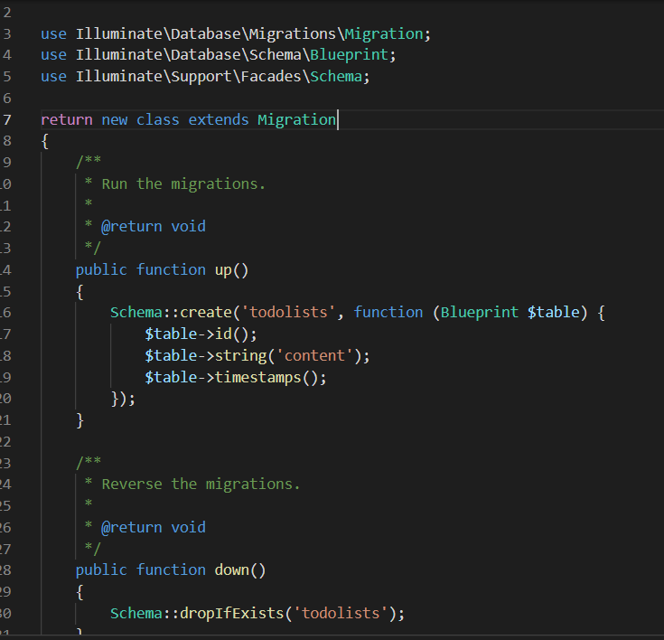

**CHAPTER 4**

***Website Snapshots with updated database***

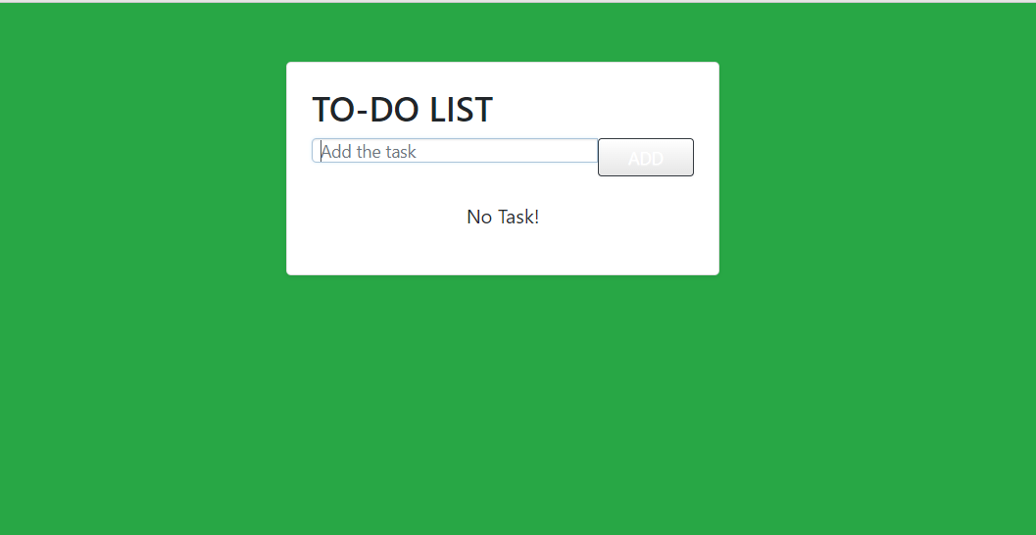

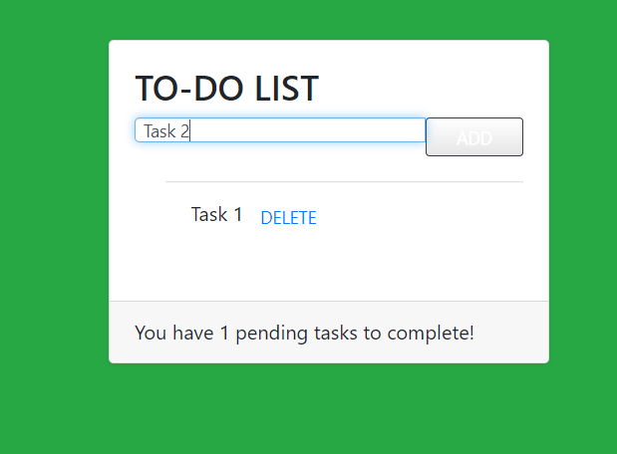

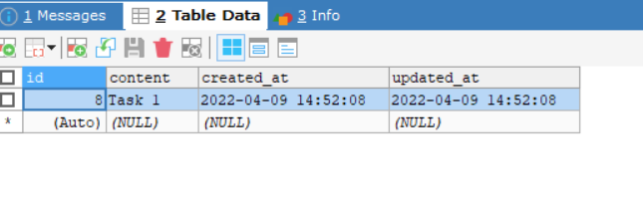

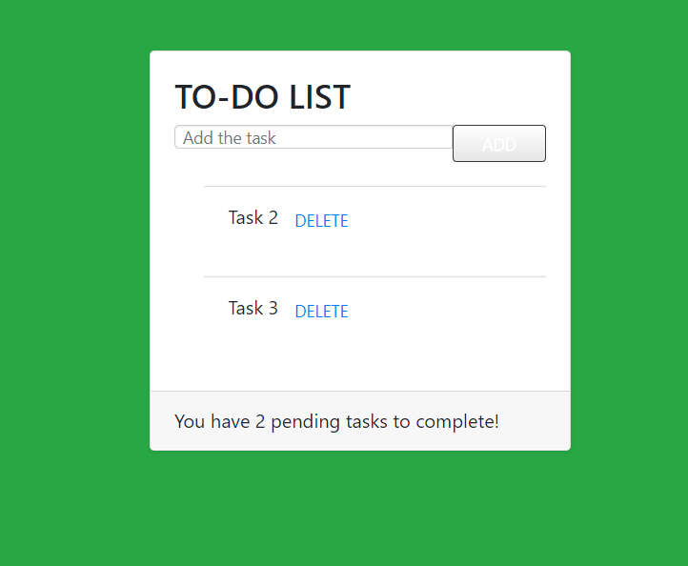

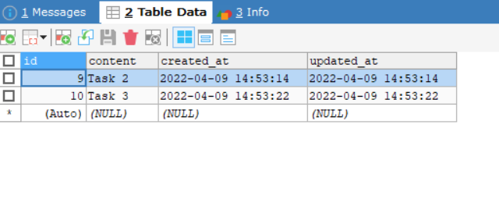

**CHAPTER 5**

***GitHub Link***

My GitHub account: <https://github.com/arushnigam>

Project Link: <https://github.com/arushnigam/mvc_project>

***References***

* [***https://www.google.co.in/?hl=hi***](https://www.google.co.in/?hl=hi)
* [***https://stackoverflow.com/***](https://stackoverflow.com/)
* [***https://www.w3schools.com/***](https://www.w3schools.com/)
* [***https://laravel.com/***](https://laravel.com/)

**THE END**

|  |
| --- |
|  |